

Assignment 1 Data Visulaization

By Enoch Denkyirah



October 18, 2024

Table of Contents

Assignment 1 Data Story Telling 2

Scenario 2

First Task 2

Policies and Procedures 2

Second Task 4

Set a password to protect the workbook 4

Change Currency to Great British Pounds (GBP) 4

Turn GDP Sheet into a Table 5

Filtering the Table 5

Making a Chart 6

Editing a Chart 6

Moving the Chart into a different sheet 7

Creating a sort for the 20 Highest Countries 7

Creating a Chart for the Sort 8

Filling the Background of a Chart 8

Macro Buttons 9

Using the Macro Button 9

Create a Header and Footer 10

Third Task 10

Data Preparation and Filtering 10

Colour Scheming (Blue/Orange for Accessibility) 11

Dashboard Layout and Charts 11

User Interaction and Filtering 14

Reflective Account 14

# Assignment 1 Data Story Telling

## Scenario

Data visualisation has become an essential business capability to help transform information into insights that can drive meaningful business outcomes and improved experiences. Today, most organizations have accumulated a wealth of data from the different corners of their businesses they are then unable to see how this data can help them make better decisions, making actions, and results.

You have been asked to Look at the data workbook and familiarize yourself with this data. You have also been asked to create a visual report that will show the data in the form of charts and maps using Tableau to the client requirements. You will also need to consider data protection and computer misuse policies.

# First Task

## Policies and Procedures

When working with this data, ‘The Wealth in Nations’ data, the policies that need to be adhered to are:

* **Data Accuracy and Integrity** - Ensure that all data processing, cleaning, and transformations are done accurately and with minimal alterations to the original data. This is essential for reliable analysis and valid results. Incorrect or manipulated data could lead to false interpretations or misleading conclusions, affecting the credibility of the analysis.
* **Transparency** - Keep detailed documentation of any changes made to the data, including cleaning, transformation, or any assumptions made during analysis. This ensures that anyone reviewing the analysis can understand the decisions made throughout the process.
* **Data Security** - Protect the data from unauthorized access by using secure storage, passwords, and encryption where necessary. It is important to ensure that the data is handled securely. Breaches or misuse of data can lead to unintentional data leaks or violations of laws depending on how the data is further used.
* **Non-Bias and Objectivity** - Ensure the analysis is objective and free from bias, by not manipulating data to fit a preconceived conclusion or personal opinions about any nation. Ethical analysis means the data should "speak for itself." Introducing bias compromises the integrity of the analysis and can distort decision-making processes or policy recommendations derived from the data.

Being aware of and adhering to these rules as a data analyst is crucial for several key reasons:

* **Ensuring Ethical Standards** - Ethical responsibility is fundamental when dealing with data. Misrepresentation, data bias, or intentional distortion can lead to unethical outcomes, such as unfair policies or harmful business strategies. Awareness of these rules ensures that data is used to reflect reality, not to serve personal agendas or unfair advantages, maintaining fairness in decision-making processes.
* **Ensuring Clear and Honest** Communication - Data visualisation and interpretation are often how stakeholders understand complex information. Misleading or poorly represented data can cause misunderstandings or lead to misguided strategies. Clear, honest, and accurate visualisations foster better decision-making and help ensure that the data’s message is correctly conveyed to non-expert audiences.
* **Protecting the Organization and Stakeholders** - Many organizations rely on data analysts to make decisions that impact finances, strategy, and even people's lives. Following these rules protects the organization from making decisions based on inaccurate or manipulated data, thereby preventing potential financial losses, inefficiencies, or reputational damage.
* **Fostering Professional Growth** - Adhering to professional standards demonstrates integrity, competence, and attention to detail. These qualities are valued in the field of data analysis and contribute to professional growth and recognition. Being aware of and respecting these rules helps establish the analyst as a responsible and reliable professional, opening opportunities for career advancement.

# Second Task

## Set a password to protect the workbook

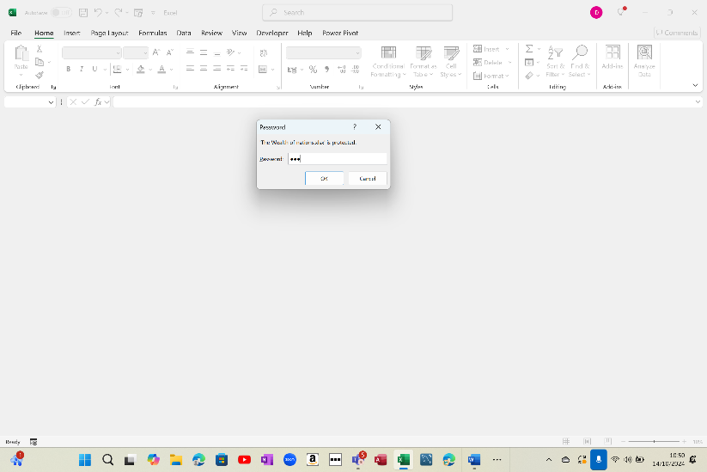Selected File and Info. I then selected the ‘Protect Workbook’ box and choose to encrypt with password. With which I then input the password to protect the workbook.

## Change Currency to Great British Pounds (GBP)

Selected Home tab and in the Number Group clicked the Format cells dialog box. In the "Format Cells" dialog box, I selected the "Number" tab and under the Category pane, clicked "Currency" and select the GBP currency symbol.

## A screenshot of a computerTurn GDP Sheet into a Table

Selected the Insert tab and selected table. I gave the range of the table which was A1 to D229 using the Ctrl, shift and arrow buttons. I ticked that my table had headers which made the data sheet into a table.

## Filtering the Table

I clicked on the filter button next to the Year of Information. From there I deselected all the years and then selected 2019 to filter out every year apart from 2019.

## Making a Chart

Select the ranking, country & GDP. I then clicked INSERT > Recommended Charts. I then clicked All Charts to see all the available chart types. When I found this chart you, I clicked it > OK.

## Editing a Chart

Using the Chart Design tab that shows once you clicked the chart, I edited the chart to my preference.

## Moving the Chart into a different sheet

I right clicked anywhere on the chart, and clicked Move Chart. To move the chart to a new worksheet, I clicked new sheet and typed an abbreviated version of the title of the chart for the worksheet.

## Creating a sort for the 20 Highest Countries

I clicked on the filter button next to the Ranking. From there I clicked Less Than or Equal To. Afterwards I typed 20 and pressed enter to filter the top 20 countries

## Creating a Chart for the Sort

## Filling the Background of a Chart

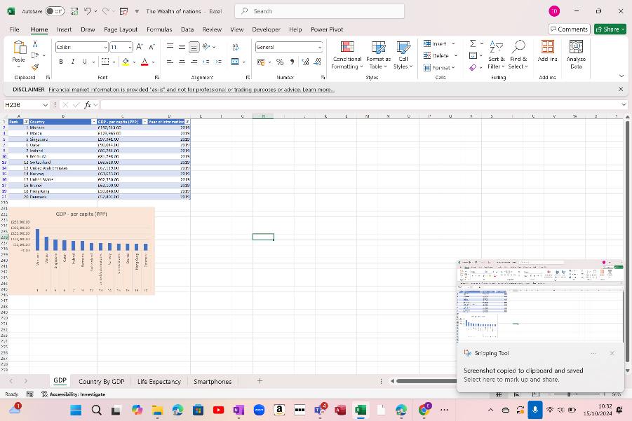

I clicked anywhere on the chart, and clicked the fill button on the Home tab. I then selected a light shade of orange to use as a background.

## A screenshot of a computer Description automatically generatedMacro Buttons

I created 3 macro buttons: print, copy and save. I created the respective macros first. For print went the Developer tab I clicked on record macro, I then labelled the macro printSheet. I proceeded to click File and Print. I then stopped the macro. Similarly, I did for save with saveSheet recording File > Save and copy with copySheet recording right clicking the highlighted sheet. To create the physical buttons, I went the Developer tab again and clicked Insert > Form Controls > Buttons. I then assigned one button to each command (print, copy, save).

## Using the Macro Button

Copied the table using the Macro button copy and inserted it into a new sheet.

## Create a Header and Footer

# Third Task

Link: [Assignment Tableau | Tableau Public](https://public.tableau.com/app/profile/enoch.denkyirah/viz/AssignmentTableau_17291690200570/Top20GDPs?publish=yes)

To form the Wealth of Nations dashboard in Tableau using only the top 20 countries by GDP, I approached the analysis with these steps and design considerations:

## Data Preparation and Filtering

I began by loading the data into Tableau, combining the three sheets (GDP, Life Expectancy, and Smartphone Users) based on the common field of "Country." After loading the data, I applied a filter to focus solely on the top 20 countries by GDP, ensuring that these countries were present across all datasets.

## Colour Scheming (Blue/Orange for Accessibility)

To make the dashboard colour-blind-friendly, I selected a blue/orange colour scheme, which is known for improving readability for those with colour vision deficiencies. Each country represents a different hue in this range of colours.

## Dashboard Layout and Charts

I structured the dashboard into five distinct sections, each with its own chart type to highlight different aspects of the data:

**Chart 1: Top 20 Highest GDPs (Bar Chart)**

* **Description**: This bar chart displays the top 20 countries by GDP (per capita, PPP). Each bar represents a country, with the length of the bar corresponding to its GDP value.
* **Purpose**: This gives an immediate visual comparison of the economic power of the top 20 countries.

**Chart 2: Smartphone Users in the Top 20 GDP Countries (Bubble Chart)**

* **Description**: The bubble chart visualizes the number of smartphone users in each of these 20 countries. The size of the bubble reflects the number of smartphone users, allowing for a quick comparison between countries.
* **Purpose**: This highlights the technology penetration in the world's wealthiest countries and provides insight into whether GDP correlates with high smartphone usage.

**Chart 3: Life Expectancy in the Top 20 GDP Countries (Table)**

* **Description**: I used a table to display the life expectancy at birth for the top 20 GDP countries. Each row contains a country name, its life expectancy value.
* **Purpose**: This provides a clear, detailed view of how life expectancy varies among the top 20 wealthiest countries, offering a way to compare health outcomes.

**Chart 4: GDP vs Smartphone Users (Bar Chart)**

* **Description**: This bar chart compares GDP against the number of smartphone users for each country, with the bars representing smartphone users and the GDP rank of each country on top of the bar.
* **Purpose**: It shows whether higher GDP countries have proportionally higher numbers of smartphone users, offering insight into technological adoption in relation to wealth.

**Chart 5: GDP vs Life Expectancy (Bar Chart)**

* **Description**: A bar chart compares GDP with life expectancy in the top 20 countries, with the bars representing life expectancy and the GDP rank of each country on top of the bar**.**
* **Purpose**: This visual comparison provides insight into whether a country's wealth correlates with longer life expectancy, showcasing any significant disparities.
* A screenshot of a computer

  Description automatically generated

## User Interaction and Filtering

To improve usability, I included filter options on the dashboard, allowing users to view specific regions. I also ensured that each chart is interactive, so selecting a country on one chart highlights it across all other visuals.

# Reflective Account

Working with Excel and Tableau as a beginner was a valuable learning experience that provided hands-on practice with data analysis tools.

**What Went Well:**

I quickly adapted to formatting data in Excel, organizing it into tables with clear labels and sorting by GDP, life expectancy, and smartphone users. This made it easier to import the data into Tableau. Navigating Tableau became smoother as I learned to create different chart types, apply filters, and adjust colour schemes using its drag-and-drop interface.

**What Could Be Improved:**

Data/visual correlation proved challenging when trying to draw deeper insights, as interpreting trends and relationships required more experience. Improving my Excel skills, such as using formulas to automate data preparation, would streamline the process. Additionally, exploring advanced Tableau features like calculated fields and custom dashboards would help drive more insightful analyses.

Overall, this project was a great introduction to data analytics.